|  |  |  |
| --- | --- | --- |
| **Motherlode Newcomers Silent Auction**  November 7, 2024 |  | **Motherlode Newcomers Silent Auction**  November 7, 2024 |
| **Description:** | Item # | **Description:** Item# |

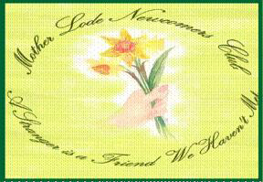

|  |  |  |  |  |
| --- | --- | --- | --- | --- |
| Name (First & Last) | Bid Amount | Name (First & Last) | | Bid Amount |
| 1. |  |  | 1. |  |
| 2. |  |  | 2. |  |
| 3. |  |  | 3. |  |
| 4. |  |  | 4. |  |
| 5. |  |  | 5. |  |
| 6. |  |  | 6. |  |
| 7. |  |  | 7. |  |
| 8. |  |  | 8. |  |
| 9. |  |  | 9. |  |
| 10. |  |  | 10. |  |
| 11. |  |  | 11. |  |
| 12. |  |  | 12. |  |

Cut in half and use for 2 items. More form will be available at the luncheon.